**Intensive Mandarin Programme**

The Centre for Language Studies (CLS) has relaunched it's highly successful Intensive Mandarin Programme in partnership with the Singapore Hokkien Huay Kuan (SHHK) Cultural Academy with effect from July 2014. Both parties have signed a Memorandum of Understanding (MOU) on 24 April 2014 to mark this partnership.

The Intensive Mandarin Programme offers 11-week modules at six different proficiency levels to cater to students' differing learning needs. Each module offers an intensive course with four hours of lessons per day over five days a week, and an examination. Certificates of Proficiency will awarded by the CLS after the successful completion of each proficiency level, consisting of two modules.

Interested participants may download the application forms from [www.shhka.com.sg/LearnChinese](http://www.shhka.com.sg/LearnChinese) . Alternatively, they can contact SHHK at [enquries@shhkca.com.sg](mailto:enquries@shhkca.com.sg) / tel: (65) 6222-8212.

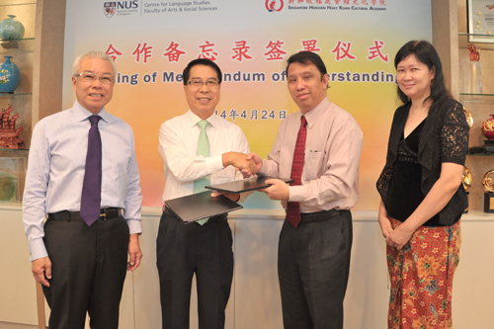

From left to right: Mr Chua Tian Poh (President of SHHK), Mr Perng Peck Seng (Vice President of SHHK),

Assoc Prof Chan Wai Meng (Director of CLS) and Prof Brenda Yeoh (Dean of Faculty of Arts and Social Sciences)